# Name: M. Hasnain Naeem (212728, B)

# React Shopping Cart

## Setup

1. Install all the node packages by running “node install” command. And do the same in “client” directory.
2. Change the MongoDB server path and database name in file named “database-settings.js” in directory “config”.
3. Run the server. That’s it.

## Screenshots

**Home Page**

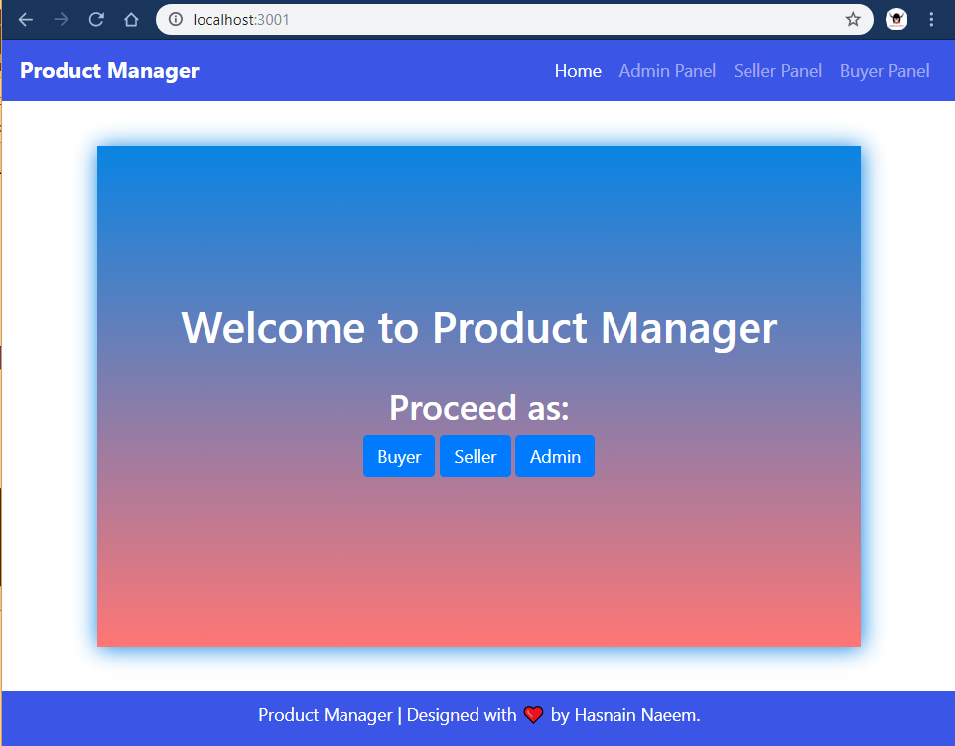

**Buyer Panel**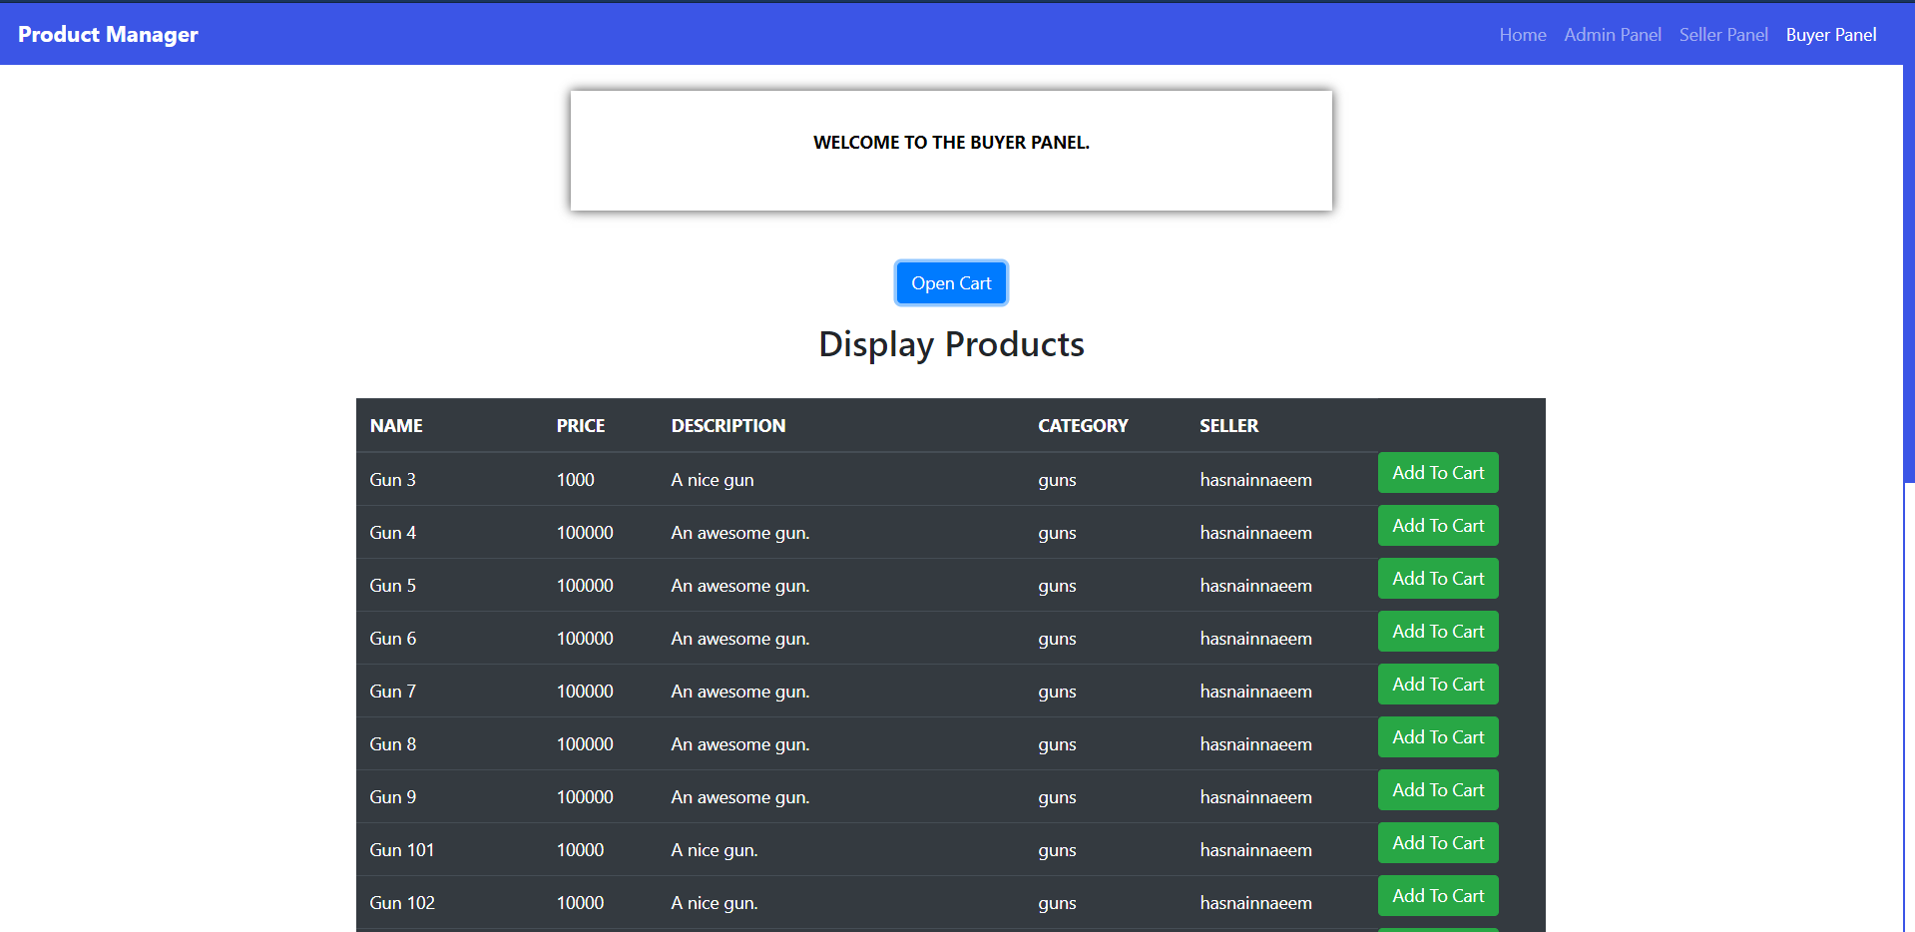

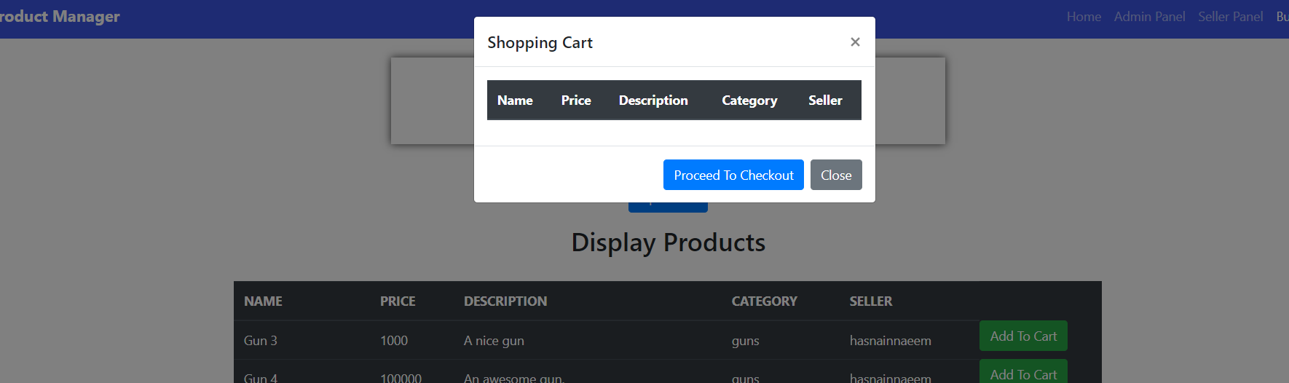

**Admin Panel**

